Friends of Dovedale

sprinG GLOw
Tuesday 13th March 2018
We hope you enjoyed your Christmas UV Glow Party as much as we did - but it was our first attempt, and we know we can do better than that!

Why didn’t white/bright clothing light up? Where was the conga line?
Did you limbo? Did you have enough glow goodies?

This time we’re going for:
More disco, laser & UV lights
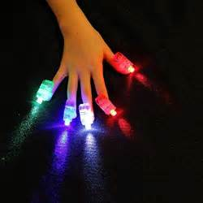
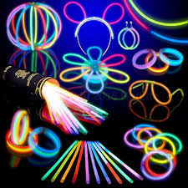
More dancing & dance games
More glow accessories

MORE FUN!

Years 3 & 4: | 4.30pm to 5.30pm
Years 5 & 6: | 5.45pm to 6.45pm

Tickets: £5 (including glow accessories & refreshments)

Let‘s glow agaiN

SPRING GLOW: TUESDAY 13TH MARCH 2018
Child’s name: |  |  |  |  |  |  | Class:
Number of tickets @ £5 each:

Please put the completed slip & correct money in an envelope and write on it your child’s name, class, amount and F.O.D. Spring Glow. Cheques payable to Friends of Dovedale.

