Support for children and young people in Liverpool with their mental health

APPS
- https://kooth.com/ - Popular App for young people - Free, safe and anonymous online support for young people.

- https://www.mypossibleself.com/ - The NHS-featured mental health and wellbeing app

Liverpool based support
- Liverpool FYI (Fun Youth Involvement) www.liverpoolcamhsfyi.com

- Mersyside Youth Association http://www.mya.org.uk 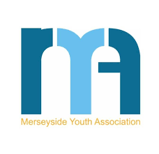
- Young Persons Advisory service - offers free counselling and small group - www.ypas.org.uk/ 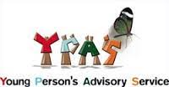
- National support
Young Minds - mental health support for young people http://www.youngminds.org.uk/
- 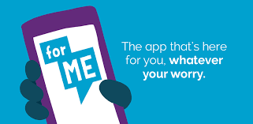Childline - https://www.childline.org.uk/ - Lots of visual and online resources as well as access to free counsellors via email and telephone.

