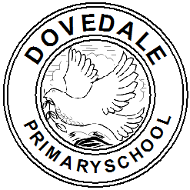

**YR Phonics Glossary**

|  |  |
| --- | --- |
| Grammar term | What does it mean? |
| **Grapheme** | A written symbol that represents a sound. This can be a single letter or a sequence of letters. |
| **Phoneme** | The smallest unit of speech. The word ‘hat has three phonemes ‘h’ ‘a’ ‘t’. |
| **Diagraph** | Two letters that, when together, make a sound.  sh  ch  th |
| **Trigraph** | Three letters that, when together, make a sound.  ‘igh’ |
| **Speed sounds** | Sounds children know, presented to them on flashcards at speed to read. |
| **Green words** | Words that contain only sounds the children have been taught. This means they can Fred talk the word and blend it to read. There are different sets of green words. |
| **Fred talk** | Fred the green frog who can only speak in sounds. The children hear the sounds, repeat and blend the sounds to read the word. We use Fred talk when spelling words. |
| **Blend**  **Blending** | Say each sound. Continue to repeat the sounds at a quicker pace until we put all the sound together to say the complete word. |
| **Red words** | These are the tricky words that cannot be sounded out with Fred talk because they do not follow the spelling rules.  ‘the’ ‘all’ |
| **Nonsense words** | Words that are not realy words but allow the children to practise Fred talk and blend.  ‘zig’ ‘fighp’ |
| **Fluency** | We say a child who reads with fluency is someone who can read aloud at a pace that flows. They are not needing to stop and Fred talk words.  (This supports comprehension.) |
| **Pure sounds** | When you say the true sound the letter makes without putting ‘uk’ at the end.  ‘mmmmmmmm’ not ‘muh’ |
| **Fred fingers** | We use Fred fingers to segment a word to be able to write it. Each finger represents a sound. We press each finger when we break up the word into sounds.  s-u-n |