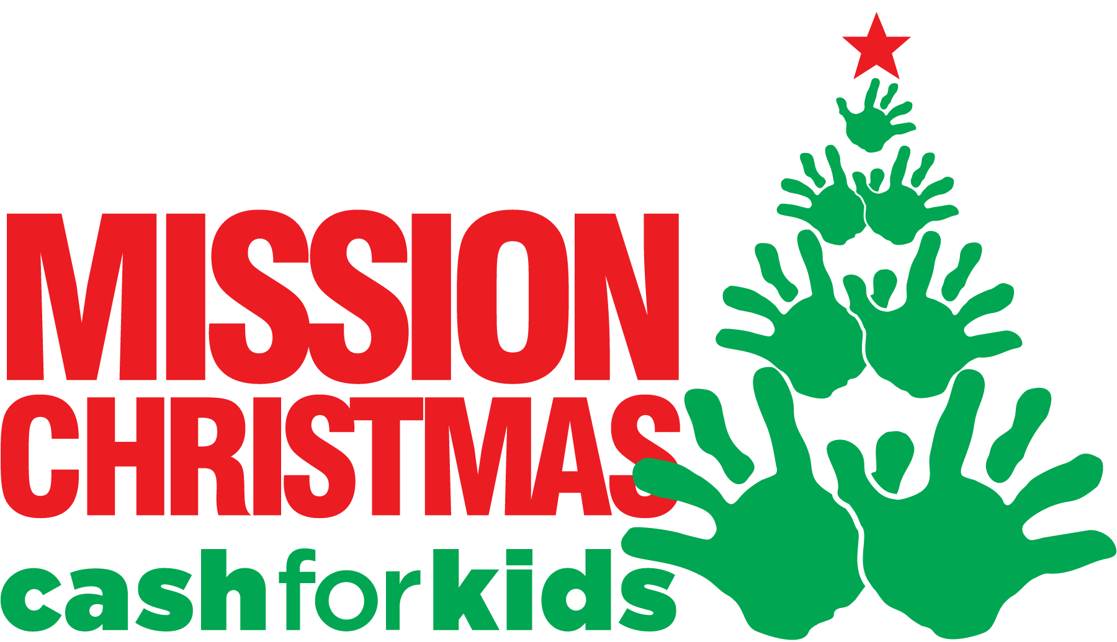
23rd November 2017

Dear Parent/Carer,
This year Dovedale Primary School would like to support a local charity to provide Christmas gifts for local children who may not otherwise receive any gifts on Christmas day.
Radio City run the campaign and they are asking you to buy an extra present that can be given to a disadvantaged local child to make their Christmas morning special. We need new and unwrapped gifts suitable for children and young people aged 0-18 years, you can donate here at school, along with other drop off points across the city. Typically items that fall short would be baby items which can be clothing, nappies, dummies and toys and also gifts for older children and teenagers. If you would like any further information about this local cause please visit www.radiocity.co.uk/mission.
We will be collecting the gifts in our school reception so please drop off there or send in with your child to class. We will update you nearer the time about the deadline once we have scheduled a pick up date but anticipate collecting gifts up to and including Friday 15th December.
Along with gift donations we will also be accepting cash donations. Please place these in an envelope labelled Mission Christmas.
We thank you in advance for your support
Yours sincerely
Mr Nik Smith
Head Teacher

