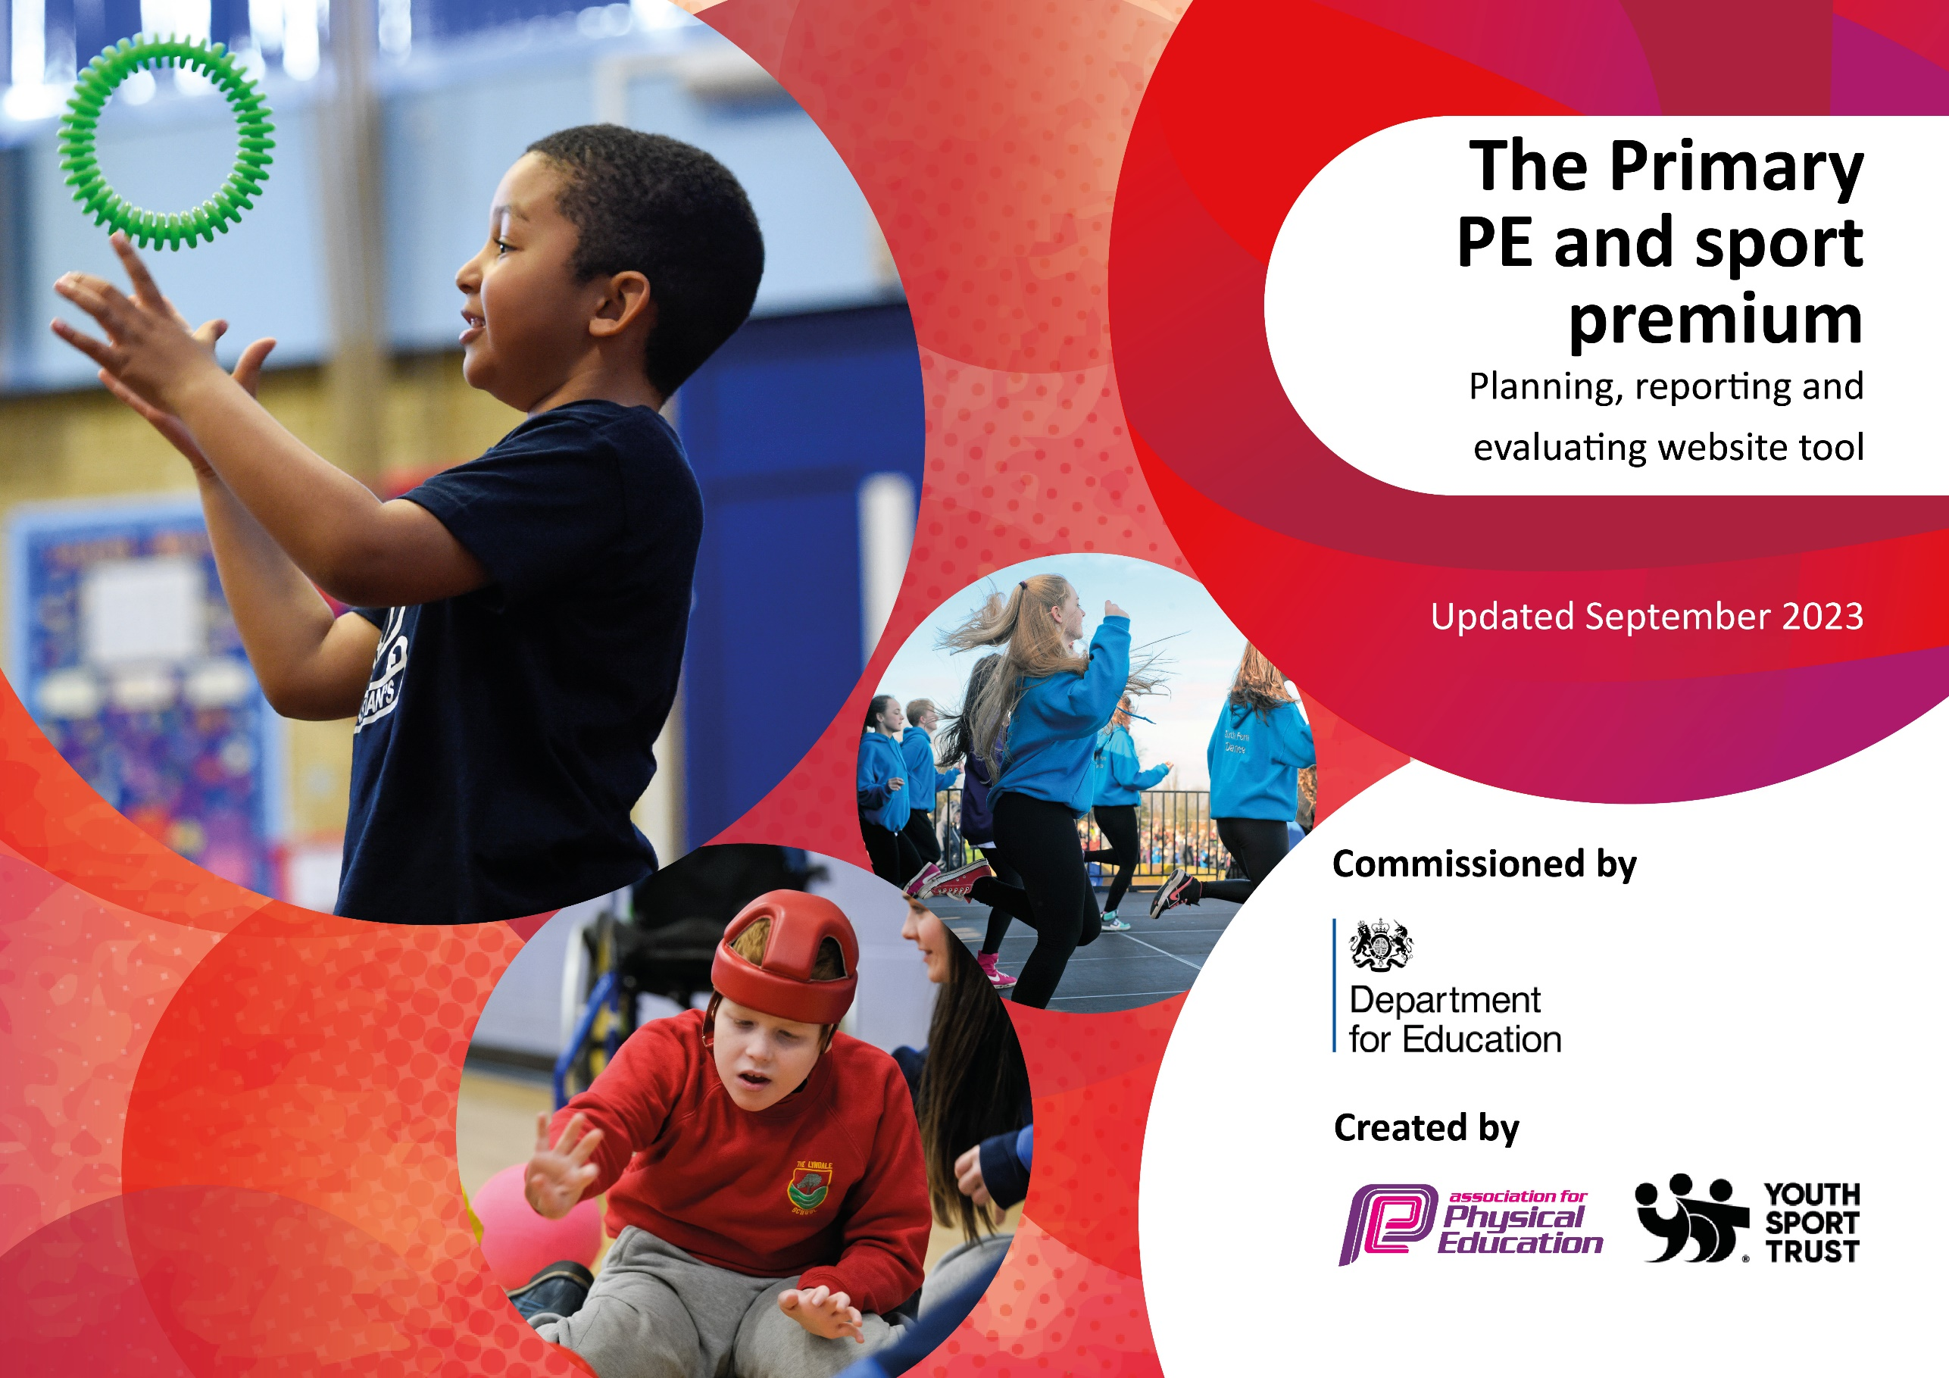

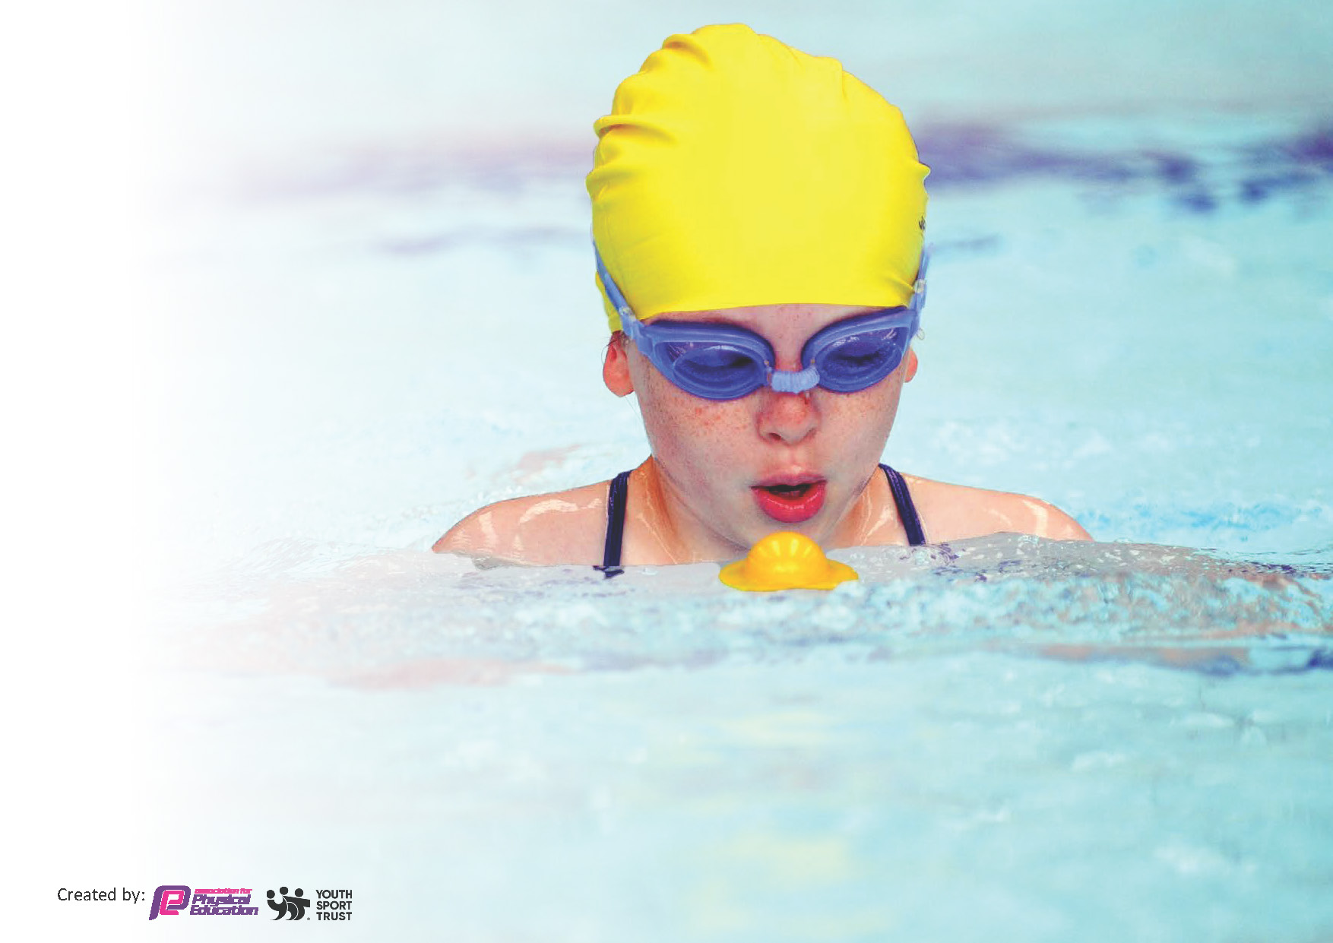
This template can be used for multiple purposes:
by:
- It enables schools to effectively plan their use of the Primary PE and sport premium
- It helps schools to meet the requirements (as set out in guidance) to publish information on their Primary PE and sport premium
- It will be an effective document to support Ofsted inspections enabling schools to evidence progress in Physical Education (PE) and evidence swimming attainment, which forms part of the PE National Curriculum. We would recommend schools consider
the Intent, Implementation and Impact of any spend, as examined within the Education Inspection Framework.

It is important that your grant is used effectively and based on school need.

Schools must use the funding to make additional and sustainable
improvements to the quality of the PE, School Sport and Physical Activity (PESSPA)
they offer. This means that you should use the Primary PE and sport premium to:

- Build capacity and capability within the school to ensure that improvements made now will benefit pupils joining the school in future years
- Develop or add to the PESSPA activities that your school already offers.

The Primary PE and sport premium should not be used to fund capital spend projects; the school’s core budget should fund these. Further detail on capital expenditure can be found in the updated Primary PE and sport premium guidance.

The Primary PE and sport premium guidance, outlines 5 key priorities that funding should be used towards. It is not

necessary that spending has to meet all the key priorities, you should select the priorities that you aim to use any funding towards.

Although completing this template is not a requirement for schools, schools are required to publish details of how they spend this funding. Schools must also outline what the impact this funding has had on pupils’ PE and sport participation and attainment and how any spending will be sustainable in the future. All funding must be spent by 31st July 202.

The Department for Education has worked closely with the Association for Physical Education (afPE) and the Youth Sport Trust (YST) to develop this template and encourages schools to use it. This template is an effective way of meeting the reporting requirements of the Primary PE and sport premium.
Review of last year’s spend and key achievements (2024/2025)

Activity/Action | Impact | Comments
Be present at more competitions across the city.  Continue the subscription to LSSP to support PE lead and staff  Continue the subscription to Diverse Dance Mix (school dance curriculum).  Daily active bursts  (Pudsey Bearpees, Active Advent,Santa Dash)  Get Set 4 PE  Enhance PE lessons with the purchase of high quality equipment.  Swimming for Y5  Enhance the playground with new equipment.  Active Breakfast Clubs (KS2) | - More opportunities than ever to be part in a range of sports across the city.  - Links made with other schools.  - Attendance at City and Regional finals.  - LSSP have support training our football teams  - Get Set 4 PE Lesson plans have supported our staff in delivering the sessions  - Links with events organisors have ensured Dovedale is included in all competitions and events.  - DD Mix has supported our dance planning.  - DD Mix have provided key opportunities such as dancing with Darcy Bussell across the school.  - LSSP / Get Set 4 PE have supported our active burst sessions to ensure extra movement for our children.  - PE Curriculum supported the purchasing of new high quality equipment.  - Athletics morning clubs have been able to continue with the purchase of new equipment.  - Quidditch club has been able to take place  - Netball club has been possible with new balls and goals.  - High quality footballs and basketballs have been purchased.  - New javelins to support training  -Great life skill  - Children feel more confident in water  - Children able to put their face in water.  - Swimmers trained for speed and technique .  - PALS trained to support playground play.  - Responsibility of the equipment  - Children involved in physical activity during lunchtimes.  - New friendships are made through team sports.  - Huge impact on wellbeing.  - Children come in to school with a smile on their face.  - 4 new breakfast clubs have taken place this year (Cross Country, Athletics ¾, Athletics 5/6 and Marathon training, Netball ) | - Awards and trophies for winning teams  - Attended 35 LSSP competitions  - Attended EFC and LSFA competitions  - Children develop strong resilence  - Training sessions – children are fitter and more active.  - Multiple city champions for KS2.  - Great success in Cross Country for both girls and boys in KS2.  - Attended National champions girls football  We have had a very successful year and taken part in more competitions.  Links have grown with EFC.  - Great feedback from parental and children voice.  - .  - More opportunities for movement and fitness  - More opportunities for different sports.  - Teamwork skills supported.  - Great CPD for the staff.  - Good links with other schools.  - More opportunities are open to the children with the purchase of new equipment.  - Children do not need to share as much equipment as more has been purchased to enhance lessons.  - Fitness skills in all clubs has improved.  - Parents very appreciative  - Growth in children taking up swimming lessons outside of school.  - Confidence has grown  - Resilience.  - Children take the role very seriously and are passionate about getting children active.  - They have targeted children who are not engaged in play so new friendships are formed.  - Children are happier on the yard.  - 40-60 children attend each club weekly.  - Children are reluctant to miss a session  - Children are happy going into school.  - Children are in school on time.

Key priorities and Planning – 25/26
This planning template will allow schools to accurately plan their spending.

Action – what are you planning to do | Who does this action impact? | Key indicator to meet | Impacts and how sustainability will be achieved? | Cost linked to the action
Broaden our initial offer of clubs/active moments.  Focus on VC. | Explore a variety of different clubs to target some cold groups across the school.  Offer KS1 free clubs  Work with 1-1 staff. | Key indictor 2- engagement of all pupils in regular physical activity  Key indicator 4 – broaden the experience of a range of sports and activities offered to all pupils.  Key indicator 3 – profile of PE and sport is raised across the school as a tool for whole school improvement. | Using Sport Apprentice to offer active plays for KS1 -KS2.  Offer KS1 clubs. | £10,000 Franke Rogers.
Sustain the offer of morning sport clubs | Staff delivering cross country and athletics clubs to KS2 pupils 3 times a week.  Netball x1 a week. | Key indicator 2- engagement of all pupils in regular physical activity  Key indicator 4 – broaden the experience of a range of sports and activities offered to all pupils.  Key indicator 3 – profile of PE and sport is raised across the school as a tool for whole school improvement. | PE sharing responsibility of the running of clubs | Equipment and staffing
Staff CPD | PE staff going in to PE lessons to support the delivery and pedagogy of PE sessions. | Key indicator 1 – increased confidence, knowledge and skill of all staff in teaching of PE and sport.  Key indicator 3 – profile of PE and sport is raised across the school as a tool for whole school improvement. | Supply booked to cover PE leads to support lessons. | Supply costs
Training for Competitions | Sports coach /apprentice. allocated time to train teams for competition. | Key Indicator 5- increased participation of competitive sport. | Holly Dwan to organise timetable to ensure all competitions get trained for. | Timetabling issue
Continue to have a huge presence in competitions across the city. | LSSP  LSFA  EFC  Gaelic Football  Holly, Jess, Frankie and Jamie to organise and train for these events. | Key Indicator 5- increased participation of competitive sport. | Holly Dwan to organize timetable to ensure all competitions get trained for. | Timetabling issue
Equipment to support teaching and competitions | Ensure equipment is up to a good standard and that we have enough to deliver high standard of lessons  Ensure resources are available to train or competitions. | Key Indicator 5- increased participation of competitive sport.  Key indicator 2- engagement of all pupils in regular physical activity | Holly, Frankie and Jamie monitor the resources and order when needed. | Cost
Swimming for Y5 and Y6 | All Y5 and Y6 pupils will have the opportunity to engage in swimming sessions | Key Indicator 5- increased participation of competitive sport.  Key indicator 2- engagement of all pupils in regular physical activity  Key indicator 4 – broaden the experience of a range of sports and activities offered to all pupils. | Nik to organsie and book sessions.  Holly to book gala and polo | Cost

Swimming Data
Meeting National Curriculum requirements for swimming and water safety.
Priority should always be given to ensuring that pupils can perform safe self-rescue even if they do not fully meet the first two requirements of the National Curriculum programme of study

Question | Stats: | Further context  Relative to local challenges
What percentage of your current Year 6 cohort can swim competently, confidently and proficiently over a distance of at least 25 metres? | 65%
What percentage of your current Year 6 cohort can use a range of strokes effectively [for example, front crawl, backstroke, and breaststroke]? | 76%

What percentage of your current Year 6 cohort are able to perform safe self-rescue in different water-based situations? | 54%
If your schools swimming data is below national expectation, you can choose to use the Primary PE and sport premium to provide additional top-up sessions for those pupils that did not meet National Curriculum  requirements after the completion of core lessons. Have you done this? | Yes/No | Top up swimming for Y5 cohort.
Have you provided CPD to improve the knowledge and confidence of staff to be able to teach swimming and water safety? | Yes/No | External coaches.

Signed off by:

Head Teacher: | Nik Smith
Subject Leader or the individual responsible for the Primary PE and sport premium: | Holly Dwan
Governor: | Claire Povlotsky
Date: | 18/7/25

