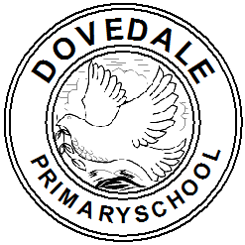

**YR Read to Write Glossary (terminology used with the children)**

|  |  |  |
| --- | --- | --- |
| Grammar term | What does it mean? | |
| **Capital letter** | Letters in the alphabet. Uppercase letters. | |
| **Full stop** | . | |
| **Finger space** | The separation of words in a sentence. | |
| **Word** | A sequence of sounds that when put together has meaning. | |
| **Fred fingers** | Assign a sound to each finger to support segmenting when spelling words. | |
| **Label** | A classifying phrase or name applied to a person or thing. | |
| **Caption** | A brief explanation accompanying an illustration, cartoon, or poster. | |
| **Clause/sentence** | A **clause** is a group of words that includes a subject and a verb. | |
| **Time adverbial** | First  Next  Then  After that  Finally | |
| **Personal pronoun** | I  you  he  she  it  we | they  me  him  her  us  them |
| **Repeated story language** | A collection of typical words and phrases which are used when writing traditional stories.  ’she ran and she ran and she ran’  ‘he climbed and climbed and climbed until he reached the top’ | |