**Autumn 1&2 Understanding the world/People and communities (history link)**

**Key knowledge**

* To know that over time humans go through life stages: baby, toddler, child, teenager, adult and old people.
* They no longer play with baby toys because of their age.
* Some toys they are playing with now were not invented when their parents were their age.

**Developing Curiosity**

* Who is the oldest member of your family?
* Is the tallest person you know the oldest?
* When is your birthday?
* If you know your arm span measurement, what else do you know?

**History**

In History, we look at things that have happened in the past.

In EYFS, we learn about the past and present by looking at our own lives and the lives of our family and friends.

**ELG: Understanding the World/People and Communities**

•To talk about past and present events in their own lives and in the lives of family members.

•To know about similarities and differences between themselves and others, and among families, communities andtraditions.

**Fun Facts**

* Babies have more bones than adults.
* Every person has a different fingerprint and each finger is different.
* Everyday a little bit of skin dries up and fall off, becoming dust.
* The biggest muscle in your body is your bottom.

**Key Vocabulary**

|  |  |
| --- | --- |
| Past | An event that has already happened. |
| Present | Something that is happening now. |
| Memories | Remembering something that has happened in the past. |
| Childhood | The time in your life when you are a child. |
| Baby | A very young child who has not yet begun to walk or talk. |
| Toddler | A young child who is beginning to walk and talk. |
| Child | A young person below the age of 18. |
| Growing up | When a person gets older. |
| In common | **Have** the same interests or opinions as someone else |
| (Facial) Features | Parts of your face such as eyes, nose, mouth. |
| Similarities | Two or more things that are alike. |
| Differences | Two or more things that are **not** alike. |

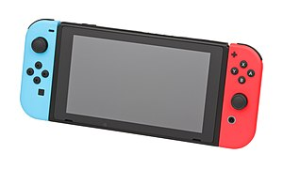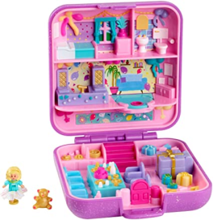

Past and present